**UltimateTech**

1) Local Computer

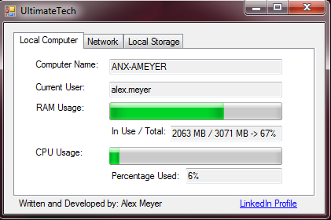

Provides information on:

-Computer Name

-Current User

-RAM Usage

-CPU Usage

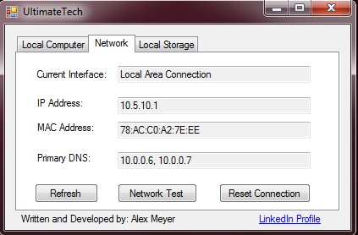2) Network

Provides Information on:

- Current Interface

-IP Address

-MAC Address

-Primary DNS

Buttons do the following:

- Refresh -> Refreshes page

- Network Test -> Pings localhost, all listed DNS servers, and Google’s homepage

- Reset Connection -> Release connection, stops and restarts Window’s networking services, then flushes DNS, and then renew’s connection

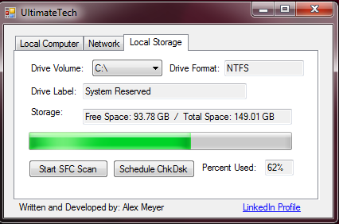

3) Local Storage

Provides information on:

-Selected drive volume

- Selected drive format

- Selected drive label

- Selected drive storage

- Selected drive percentage used

Buttons do the following:

- Start SFC Scan -> Starts an SFC scan using the following command: sfc /scannow

- Schedule ChkDsk -> Starts a chkdsk using the following command: chkdsk /R <Drive Letter>